Dear Pastor and Church Family, January/February 2020

We have so much to be thankful for! We arrived in Italy around noon on the 26th of February. In the time leading up to our departure, we were able to spend some quality time with our church family, and that was such a blessing. God also allowed our packing process to go smoothly as well and we ended up with just the right amount of bags to get all of our things over to Italy. We had 19 bags and totes in total, and I had calculated that we would be paying $1,700 in baggage fees, even with our free bags. After our check-in was all said and done we only paid $700 in baggage fees. That was certainly a great way to start the journey!

Upon our arrival in Bologna, we were greeted by men in bright-orange, bio-suits. They were screening all of the passengers for the Coronavirus. I’m praising the Lord that we did not have it, nor did we get stuck in a random city along the route due to flight cancelations. Our flights went from Chicago to London, and then from London to Bologna. On that same day, the flight from London to Milan had been canceled. In Bologna itself, you do see people wearing masks around town, but other than that it does seem like it is busniss-as-usual for most people. The virus is becoming a big deal in Italy, but at the end of the day, we know that God is in control and He has it all figured out.

Please pray for us as we continue to press on. We got tax ID’s for everyone this past Friday and that in itself was a miracle. We walked in the office as many others were waiting already. In essence, the man at the front let us skip the line and we were done in about an hour. Please pray for our housing, as many catch-22 situations are directly linked to having a house. Please pray for my wife. The final days of packing and travel have caused some post-natal pain. There is so much more to say, but this I know: God has been good!

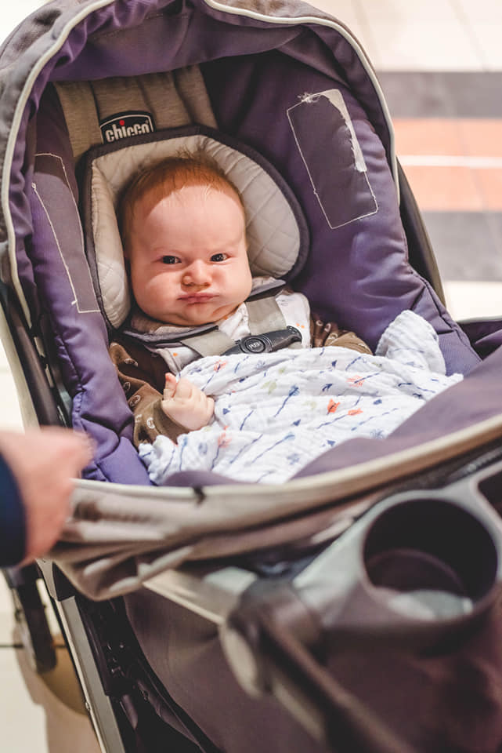
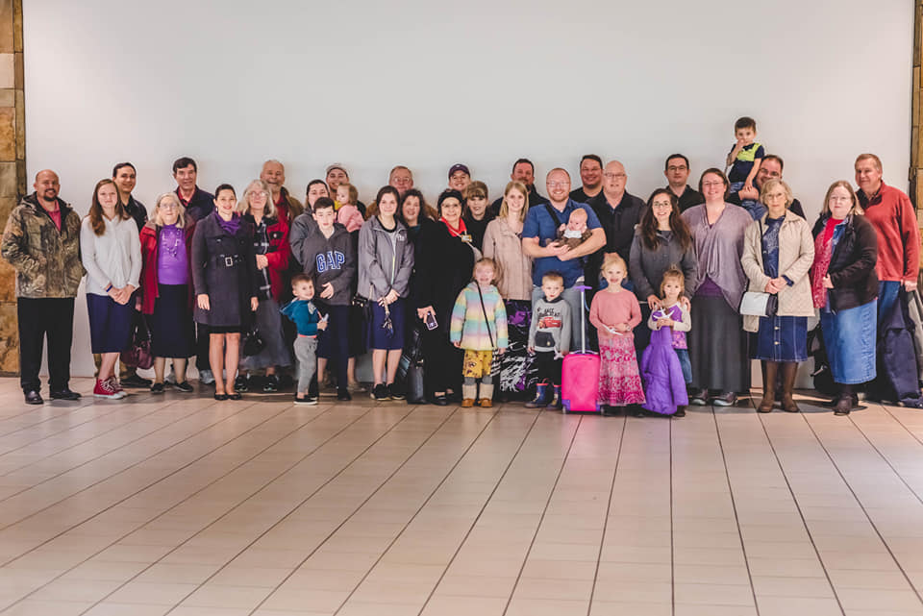
In Christ,
The Keister Family

Prayer Requests:
*Housing
*Citizenship process
*Language study
*For God to call Italian men
*Translation Projects
Saying goodbye to church family and friends.
Levi is excited to fly.

